Thermo Dynamics
Quantum Physics
F = m a
Hydrogen
Atom
Classical Mechanics
A
B

Particle Detector
}
h-bar
Measurement
Position, Momentum, Uncertainty

Schroedinger’s Equation
Nodes
Anti-Nodes

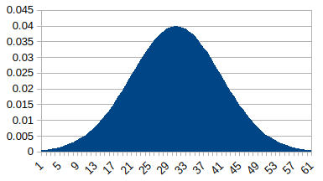
Probability

Scattering

Energy & Potentials
V1
V0
0
-a
a
I
R
T
I
II
III
A
B
C
D
F
G
V1
V0
0
-a
a
-V1
V0
0
-a
a
V0
0
-a
a
V1
-V1
0
-a
x
V0
a

Harmonic Oscillator

Angular Momentum

Emitter
Magnets
Spin

Hydrogen Atom

